

**An Undergraduate Internship/Project on**

**Laravel E-Commerce**

By

**MD. Wahid Hassan Fuad**

Student ID: **1730149**

**Spring, 2022**

Supervisor:

### Sanzar Adnan Alam

Lecturer

Department of Computer Science & Engineering

Independent University, Bangladesh

**May 09, 2022**

Dissertation submitted in partial fulfillment for the degree of

Bachelor of Science in Computer Science

Department of Computer Science & Engineering

**Independent University, Bangladesh**



Attestation

This is to certify that this whole report was completed by MD. Wahid Hassan Fuad (ID-1730149) submitted in partial fulfillment of the requirement for the Degree of Computer Science from Independent University, Bangladesh (IUB). It has been completed under the guidance of Sanzar Adnan Alam. I also certify that all my work is original and has not been submitted earlier to this university or any other institution. All the sources of information used in this Project Report have been duly acknowledged in it.

5/09/2022



Signature Date



Name: MD. Wahid Hassan Fuad



**1 |** P a g e

Acknowledgement

Firstly, I would like to thank my parents and my family members. Without their accomplishment and support, I would not have come this far to achieve what I have now. They taught me to be kind and respectable to my surroundings and treat everyone with compassion and love. They also taught me to learn every day, because knowledge maketh man.

I would also like to acknowledge the support and guidance of my faculty members and peers at my university, Independent University, Bangladesh. I would also like to thank my respected supervisor, Sanzar Adnan Alam, Lecturer, Department of Computer Science and Engineering, for his advice and suggestion to complete the report and my internship project throughout the semester.

Furthermore, I would like to acknowledge and thank the DCTO of SSL Wireless, Md. Iftekhar Alam Ishaque, for providing me the opportunity to work with his company. Thanks to Mohammad Bahar Uddin for guiding and supporting me to complete the project under his team.

It was a learning journey and a fantastic journey with Independent University, Bangladesh. My regards and respect to all of my faculty and company members. Everyone was a crucial and vital part of my journey in completing my Bachelor’s Program in Computer Science (CSC).



**2 |** P a g e

Letter of Transmittal

April 21, 2022,

Sanzar Adnan Alam (Lecturer)

Department of Computer Science & Engineering

Independent University, Bangladesh (IUB)

Bashundhara R/A Dhaka 1229, Bangladesh.

**Subject:** Report Submission for Internship

Dear Sir,

With due respect and honor, I would like to submit my internship report for the purpose of completing my Bachelor of Computer Science and Engineering Degree. I prepared this report following the experience and what I have learned during my internship period at SSL Wireless, starting from 16th of January till 17th of April, 2022. I was assigned as a web developer intern in the development team.

In SSL Wireless, I worked under the supervision of Mohammad Bahar Uddin, Project Manager & Team Lead. This report is based on my assigned project for the internship at SSL Wireless, where I was assigned to build an E-Commerce Website using Laravel. I was assigned as the frontend developer and had been instructed and guided to implement a few backend developments as well. My experience as a web developer intern with SSL Wireless has been a journey of fulfilling experiences in the corporate world and a source of knowledge. I got the opportunity to enhance my skills and knowledge regarding various factors of the real world, which will always stay with me and benefit me in the

**3 |** P a g e



long run. I would also like to acknowledge your immense guidance and advice throughout my journey in the internship program which has helped me to complete my project.

I pray and hope to have given a thorough content in this report which will elaborate clarification of information and fulfill your expectations. I would also like to thank you for giving me the opportunity to submit my report successfully.

Sincerely yours,

MD. Wahid Hassan Fuad

1730149



**4 |** P a g e

Evaluation Committee

.....................................................................

Signature

.....................................................................

Name

.....................................................................

Supervisor

.....................................................................

Signature

.....................................................................

Name

.....................................................................

Internal Examiner / Panel Member

.....................................................................

Signature

.....................................................................

Name

.....................................................................

External Examiner / Organizational Supervisor

.....................................................................

Signature

.....................................................................

Name

.....................................................................

Head of the Department / Convener



**5 |** P a g e

Abstract

Bangladesh has been growing in the aspect of digital advancement all throughout every industry. The number of internet users is increasing day by day because the internet enables fast communication amongst people and makes life easier. Therefore, it demands and requires that the businesses shift to a digital platform so they can reach a greater audience and communicate with them much easier and showcase their services and products on a more convenient platform. From startups to small businesses right through to huge brands, there are a huge number of companies that can benefit from their own ecommerce website, where they can sell their own products or services. In today’s competitive and convenience focused society, no longer do consumers want to venture to the high street in order to buy items, instead consumers want to shop from their own homes, making ecommerce a flexible solution for both businesses and buyers.

Ecommerce offers business a whole range of opportunities, from marketing opportunities to increasing your products ranges to generating more sales and with an optimised and well-developed website a business can not only achieve these goals but also offer the business’ customers around the clock, convenient service, that can boost the business.

Keeping these lustrous factors in mind I took this project. I was warned by my supervisor that even an esteemed develop would require around 4 to 8 months to build up a modern E-Commerce website. I still took the risk and inevitably was not able to build up an E-Commerce website from scratch on my own. This internship was mostly about discovering the learning path that any software engineering student will have to take if he/she wishes to flourish in this field.





**6 |** P a g e

**Contents**

|  | Attestation | |  | 1 |
| --- | --- | --- | --- | --- |
|  | Acknowledgment | | | 2 |
|  | Letter of Transmittal | | | 3 |
|  | Evaluation Committee | | | 5 |
|  | Abstract | |  | 6 |
| 1 | **Introduction** | | | 8 |
|  | 1.1 | Overview/Background of the Work . . . . . . . . . . . . . . . . . . . . . . . . . . . . . . . | | 9 |
|  | 1.2 | Objectives . . . . . . . . . . . . . . . . . . . . . . . . . . . . . . . . . . . . . . . . . . . . . . . . . . | | 9 |
|  |  |  | |  |
| 2 | **Literature Review** | | | 10 |
|  | 2.1 | Relationship with Undergraduate Studies . . . . . . . . . . . . . . . . . . . . . . . . . | | 10 |
|  |
| 3 | **Methodology** | | | 11 |
| 4 **Body of the Project** | | | | 11 |
|  | 4.1 | Work Description . . . . . . . . . . . . . . . . . . . . . . . . . . . . . . . . . . . . . . . . . . . . | | 12 |
|  | 4.2 | Journey with HTML, CSS and Javascript . . . . . . . . . . . . . . . . . . . . . . . . . | | 12 |
|  | 4.3 | Pathway to Laravel . . . . . . . . . . . . . . . . . . . . . . . . . . . . . . . . . . . . . . . . . . | | 14 |
|  |
|  |
| 5 **Lesson** **Learned** | | | | 28 |
|  |
| 6 **Conclusion** | | | | 29 |
|  |





**7 |** P a g e

**Chapter 1**

**Introduction**

An internship at a company, enables the students to gain expertise and learn the ways of the real-life actions that actually take place in a corporate world. These learnings allow the students to prepare their understanding accordingly and make it easier when applying for jobs right after graduation. It is an opportunity that comes with a high level of advantage in one’s professional life.

At the moment, I am a final year student at Independent University, Bangladesh (IUB) & doing my major in Computer Science and minor in Management Information Systems. And currently in order to graduate we have to complete a mandatory course, which is the Internship Program (CSE499). This course provides the students to implement the knowledge & skills which they have acquired in their undergrad in the real-life situation by collaborating and providing their services to a company or firm which specializes in Software Development or IT.

**1.1 Overview/Background of the Work**

The company where I am doing my internship is called SSL Wireless. SSL Wireless mounts on its decade long industry experience, superior technical skills and highest quality of support services to provide scalable IT solutions as a leading Software development and services company. It has deep infiltration in the Value-Added Services, Banking, Corporate, and FinTech industry of Bangladesh.

SSL Wireless has helped launch Mobile VAS and SMS Banking for the first time in Bangladesh, which has transformed into mobile financial services today. SSL is one of the key players behind popularizing value-added services, e-commerce & fintech services in the telecom and financial sector over the past decade that are used by millions of people today. SSL operates one of the first and the largest payment gateways SSLCOMMERZ in Bangladesh which is licensed as a Payment Systems Operator (PSO) by Bangladesh Bank and PCI DSS certified. SSL is connected to 20+ digital payment channels in its gateway. It is working with startups, corporates & government to enable them to accept payments digitally from the customers.

SSL has been working with various international corporations from different industries such as Visa, MasterCard, UnionPay, Symantec, Digicert, AWS, SAP, BPC, etc. Crossing the border, SSL Wireless has developed and deployed a Digital Wallet platform called FastPay for the first time as a Software Company from Bangladesh aiming to expand itself across international borders.



**8 |** P a g e

**1.2 Objectives**

* The growth in ecommerce brings many benefits for a business’s bottom line. So if I gain skill to develop an E-Commerce website, I will be able to position myself anywhere in the corporate world.
* Learn how a thriving software firm like SSL Wireless operates.
* Learn from my mistakes and understand that like in any other field, flourishment software engineering sector can only be achieved through one’s own consistency in self-learning practices and perseverance.



**9 |** P a g e

**Chapter 2**

**Literature Review**

**2. 1 Relationship with Undergraduate Studies**

The courses I have taken and enrolled in during my undergrad years have been enlightening me along the way and I can relate my academics to my work in a practical way, which has been helping me achieve many tasks and understand them in a better way.

* **System Analysis and Design (CSE307):** This course has taught me the analytics of a Software Development Life Cycle (SDLC) and also helped me learn a great deal about the Functional & Non-Functional Requirements and taught me about the UML Diagram which has helped me understand the backbone of designing and structuring a system.
* **Web Application and the Internet (CSE309):** This has been the most important course I have taken in my undergrad since I aspire to become a full-stack web developer, this course has taught me the basics of how to develop a website from scratch & which tools are the most necessary to develop a system. The fundamentals of HTML, CSS, Bootstrap, JavaScript, & JQuery, the understanding has enabled me with the ease of implementation in real-life projects.
* **Software Engineering (CSE451):** The basics of software engineering start from gathering requirements & understanding the scope of work and how every requirement will align with each other to build a successful system to know all the steps & methods of the SDLC, this course helps me relate all my understanding and knowledge in the real-life situations.
* **Software Testing and Quality (CSE458):** This course has enabled me to think that how quality testing of any system is important for the usability of the system and how impactful it is with respect to a smooth software system or a website taught me the application of Testing Tools.





**10 |** P a g e

**Chapter 3**

**Methodology**

In any modern software development firm, the ideology of breaking down tasks & processes are something which is implemented in order to enable the company to deliver a product quickly and with the best of the outcome. The breaking down of the phases improves the design of the system & improves the project management for that particular system. There are mainly 7 phases in a Software Development Life Cycle (SDLC), they are as follow,

1. Planning
2. Analysis
3. Design
4. Development
5. Testing
6. Implementation
7. Maintenance

The most commonly used methodologies in the software development firms are:

* Agile Methodology
* Waterfall Methodology
* DevOps
* Spiral
* Iterative
* V-Model

The Software Development Life Cycle (SDLC) Methodology that we are going to implement in our project is Agile Methodology, as this methodology breaks down the phases into numerous phases within them and this enables the tasks to be executed faster and with the efficient result. As all the features don't require to be developed or executed one after the other, so this enables the tasks to be executed whenever it is needed and the client’s feedback is gathered upon that execution and if it needs changes, it will be implemented as it will be quick on acting on the feedback. This helps the developers and project managers have better control of the project and doesn’t lose grasp.



**11 |** P a g e

**Chapter 4**

**Body of the Project**

**4.1 Work Description**

My work within the project is to be able to assist in developing the front-end of the system with my assigned team of web developers, for which we have used HTML, CSS, JS, Bootstrap and I have been assigned to assist with the backend of the system and learn from experience. In the backend, we will be using Laravel and MySQL for the system’s database. Laravel is an open-source PHP web framework used to build sites & web apps.

It has a smooth learning curve, removes some quirks of building with PHP, and has many modern built-in libraries. Some say it's the Ruby on Rails PHP equivalent.

**4.2 Journey with HTML, CSS and Javascript**

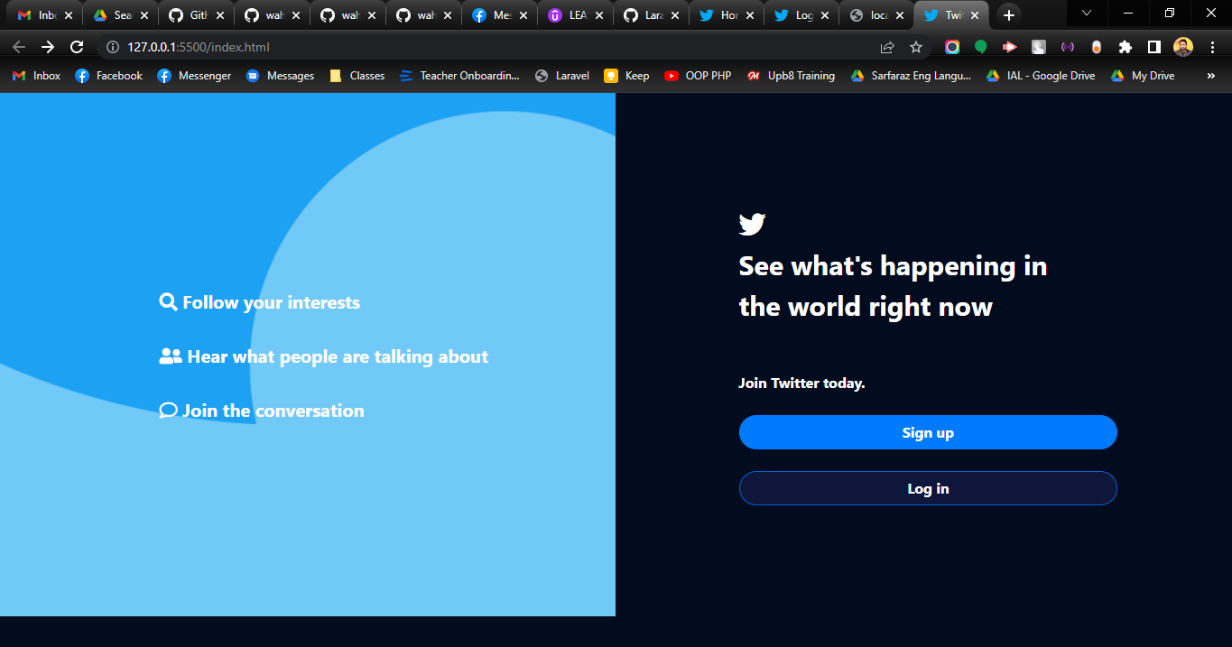  
Fig: Frontend of Twitter clone made from scratch to brush up HTML and CSS skills



**12 |** P a g e

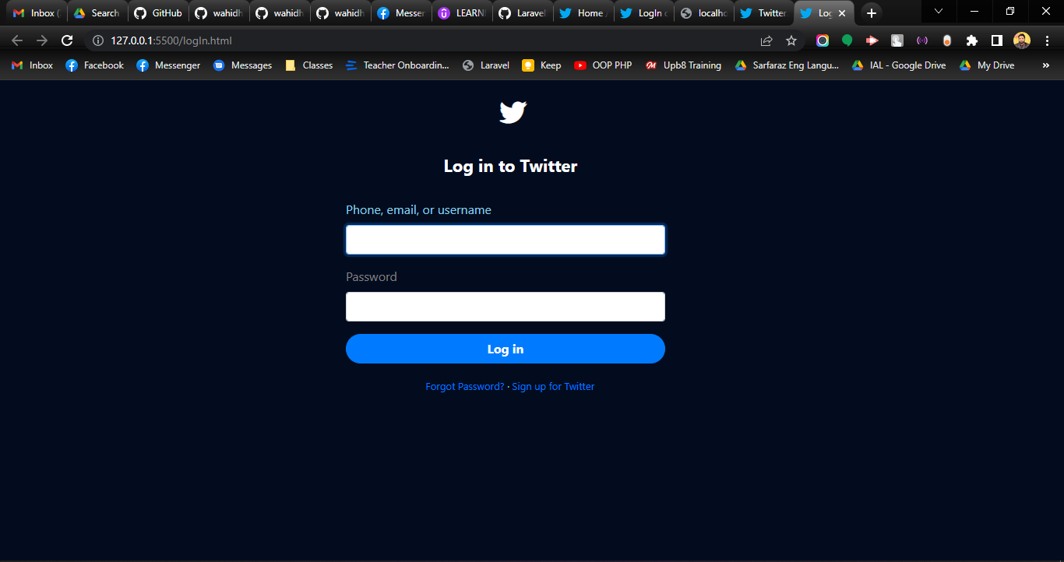  
Fig: Frontend of Twitter clone made from scratch to brush up HTML and CSS skills

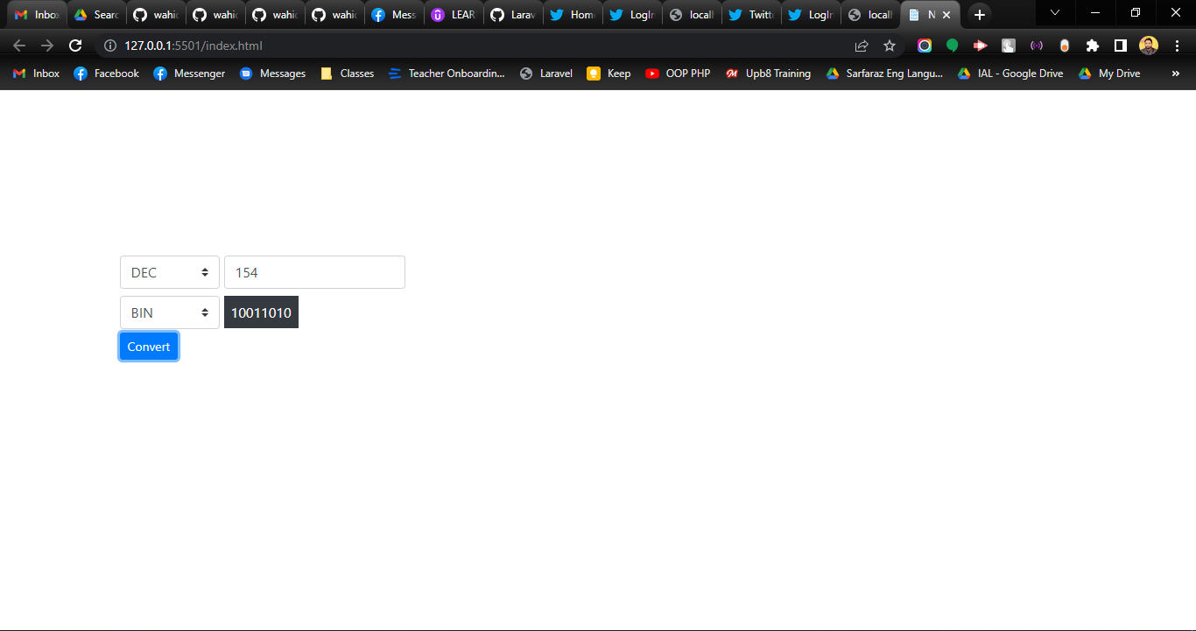  
Fig: Frontend of Number System Converter made from scratch to brush up Javascript skills

**13 |** P a g e

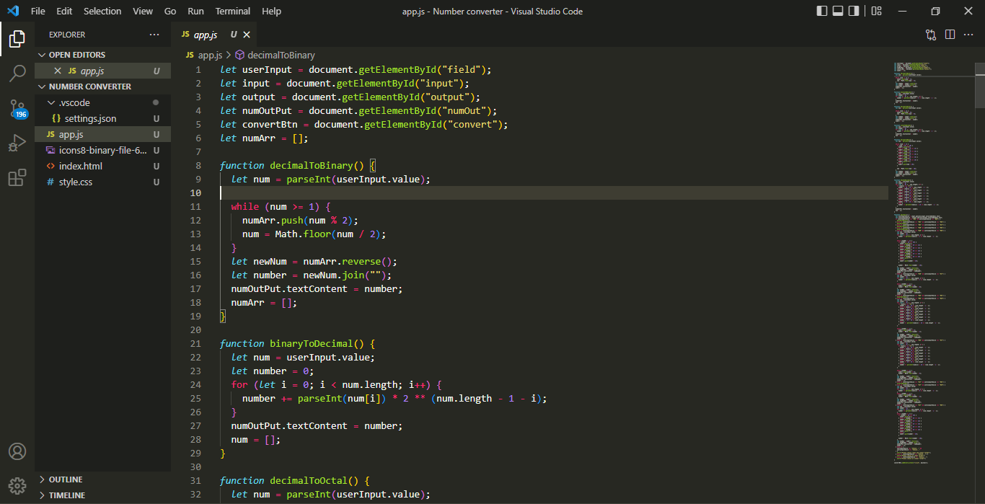

Fig: Codes used in “Number System Converter” project made from scratch to brush up Javascript skills

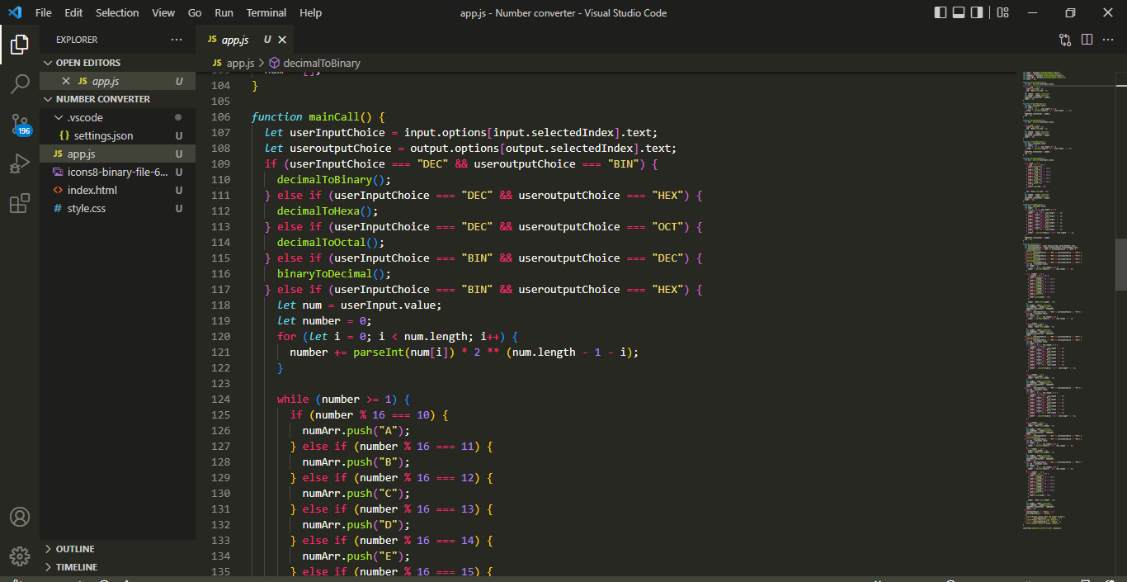

Fig: Codes used in “Number System Converter” project made from scratch to brush up Javascript skills

**4.3 Pathway to Laravel**

After going through extensive practice with HTML, CSS and Javascript and raw PHP and MySQL for several weeks, I finally gained enough confidence to switch to Laravel. These were fragments of what I learned so far

Steps

1. Install **composer**. Switch to the project folder and type ‘cmd’ in the address bar**.** Run the following command to create a project called **basic**

**composer create-project --prefer-dist laravel/laravel basic**



**14 |** P a g e

Tip

1. Go to the project directory and type cmd. Enter the command ‘**php artisan serve**’ and get the server link for your project.

Basic point

1. Laravel uses one of the design patterns called MVC (model, view and controller) pattern.
2. Database related everything will be located in **models** folder.
3. Managing things such as database is done using the **controllers** folder.
4. CSS, JS and image files are located in the **public** folder.
5. Every page that is to be viewed is created in **resources/views** folder.
6. Every route is managed from **routes/web.php**.
7. App URL and database connection info is located in **vendor/env**

**What is MVC?**

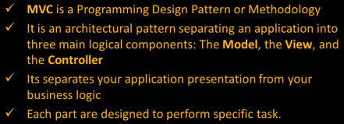

**Benefits of MVC**

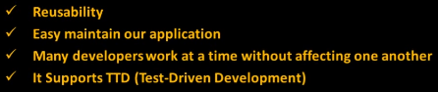  
  
  
  
  
  
  
  
  
  
  
  
  
  
  


**15 |** P a g e

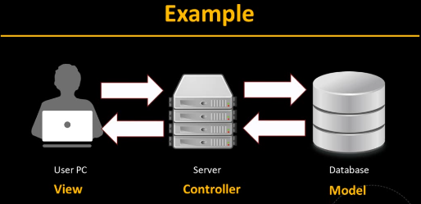  
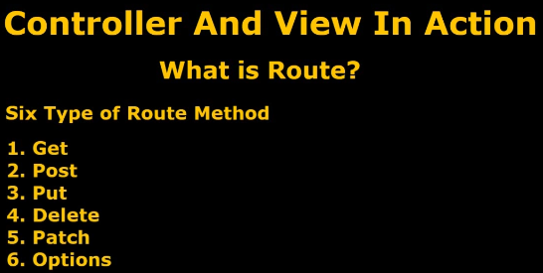

**Creating Controllers**

Move to the project directory, open cmd and type **php artisan make:controller FuadController**

**16 |** P a g e

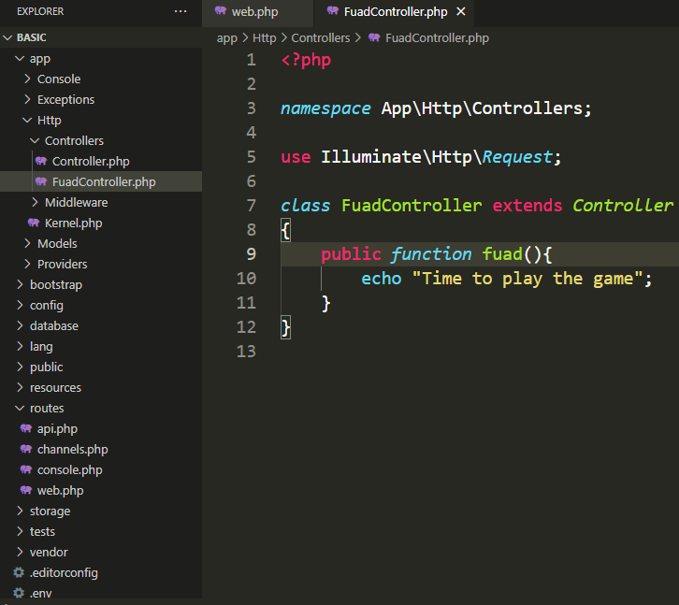  
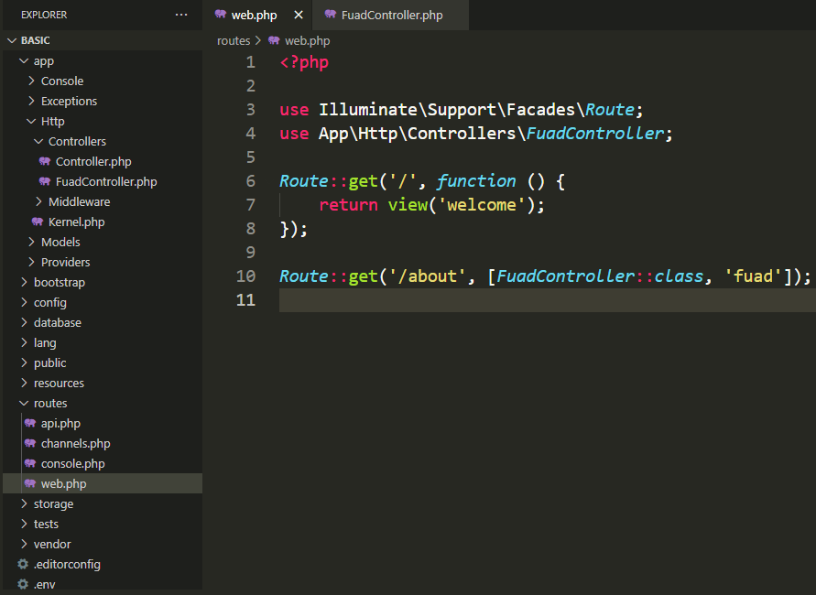

When **http://localhost/laravel8/basic/public/about** page is loaded the public function **fuad()** is invoked.  


**17 |** P a g e

**What is Middleware**

Middleware is basically a piece of code that can filter out the user request. There are two types of Middleware in Laravel. The **Global Middleware** will run on every HTTP request of the application, whereas the **Route Middleware** will be assigned to a specific route.

**Creating Middleware**

1. Move to the project directory, open cmd and type **php artisan make:middleware Age**
2. Register the middleware as shown below  
     
   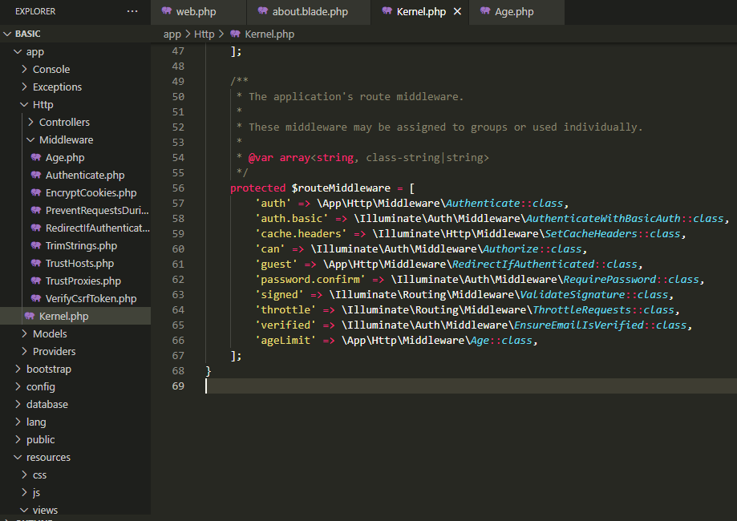



**18 |** P a g e

1. Add necessary conditions to the **Age.php** file located in **Middleware** folder  
     
   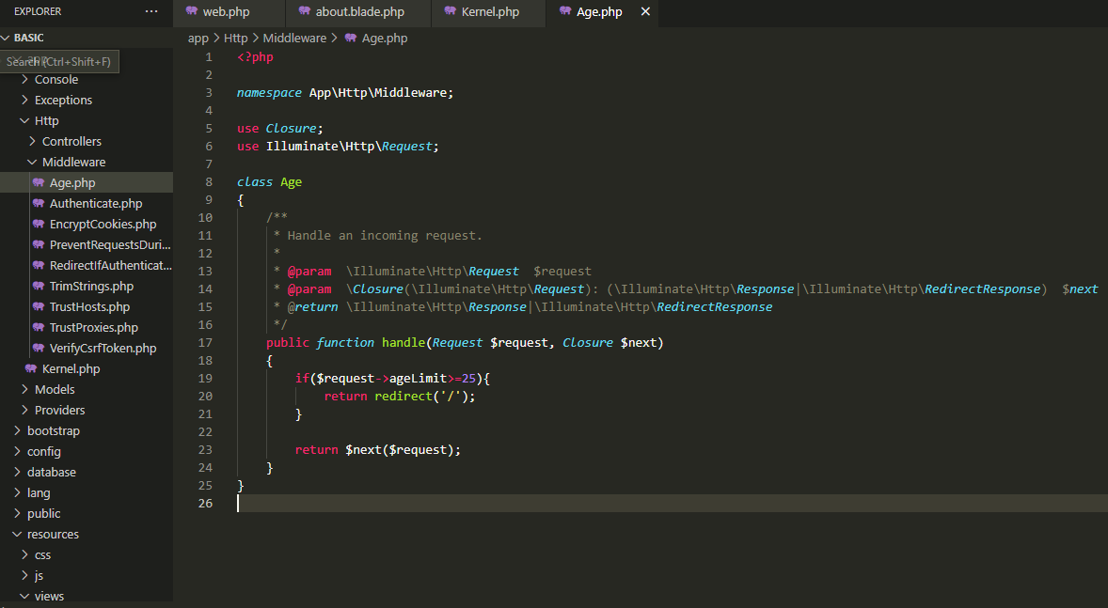
2. Add the following code to the route 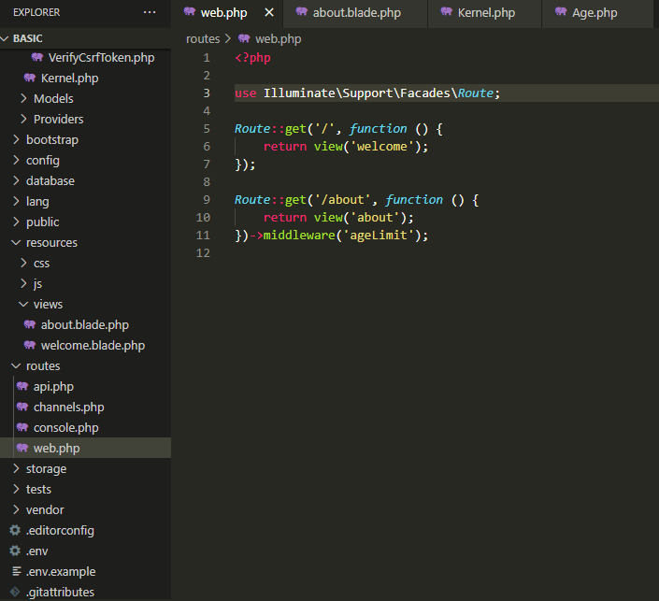

**Laravel Route** (Laravel’s **blade** **syntax** about linking web pages)

**  
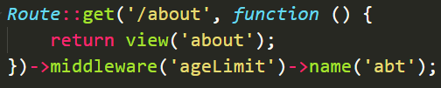**

Installing **Jetstream**  
Jetstream provides the implementation for our application's login, registration, email verification etc. To install Jetstream

1. Move to the project directory, open cmd and type **composer require laravel/Jetstream**
2. After its done type **php artisan jetstream:install livewire**
3. Type **php artisan migrate**
4. Type **npm install && npm run dev**

**Where to place Bootstrap scripts?**

1. Copy Boostrap scripts and paste them into **resources/views/layouts/app.blade.php** to render Boostrap features.



**20 |** P a g e

**Displaying data using Eloquent ORM**

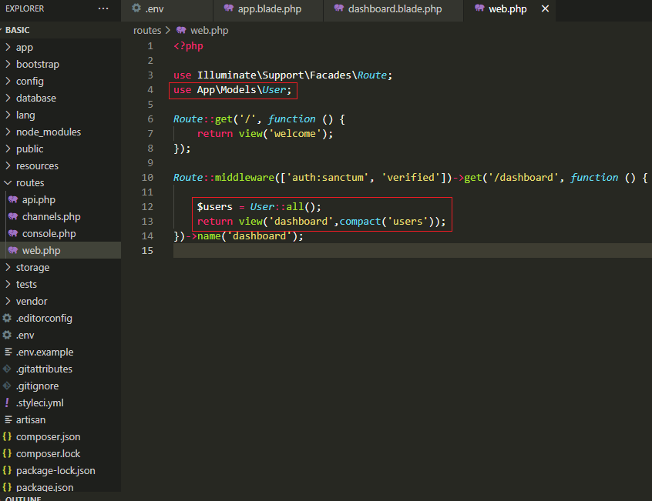

**Note:** The **compact()** function is used to convert given variable to an array in which the key of the array will be the name of the variable and the value of the array will be the value of the variable.

**Note**: Carbon is a package by Brian Nesbit that extends PHP's own DateTime class. It provides some nice functionality to deal with dates in PHP.

**Displaying data using Query Builder**

Add **use Illuminate\Support\Facades\DB;** in order to use Query Builder to display data

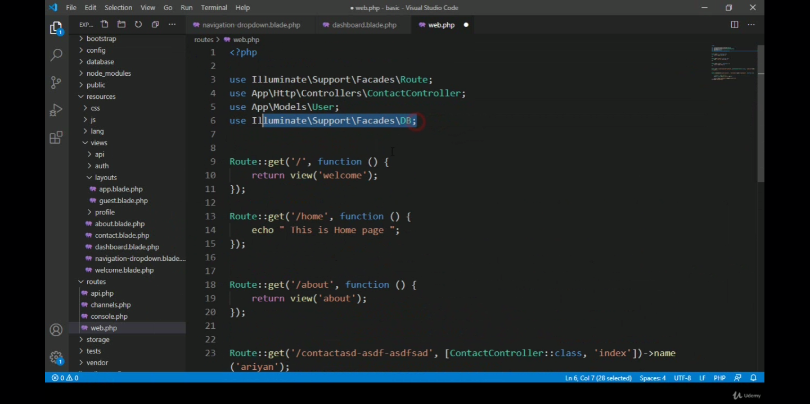

**21 |** P a g e

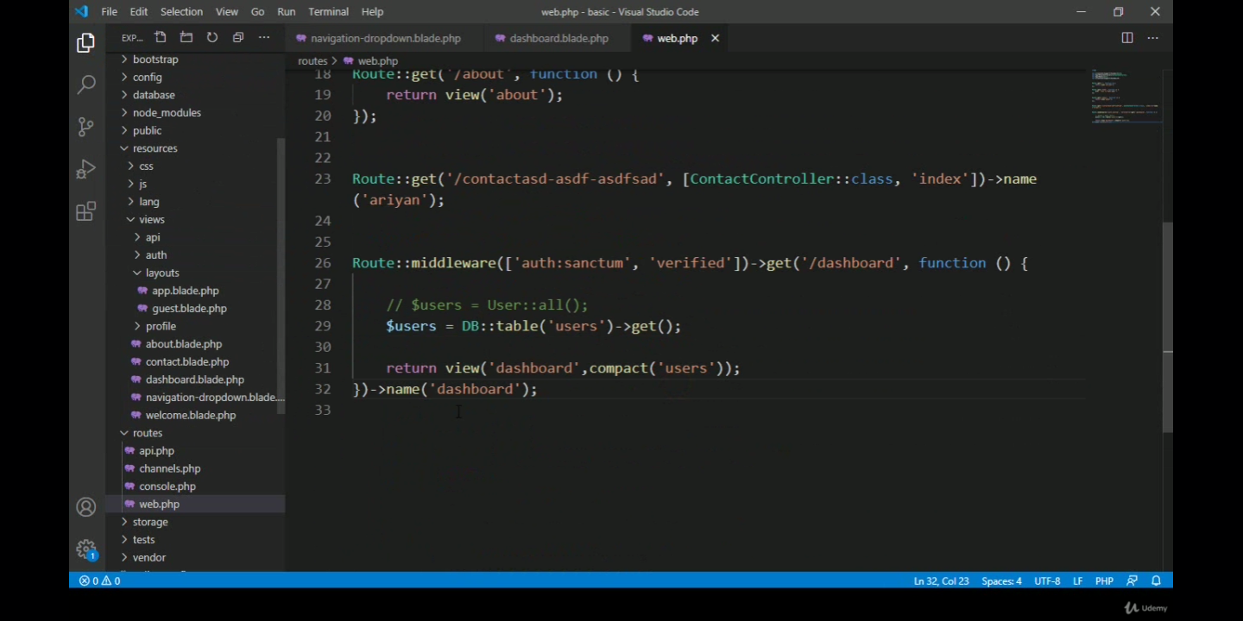

To make **difffForHumans()** function to work for Query Builder, use it like the following snippet.

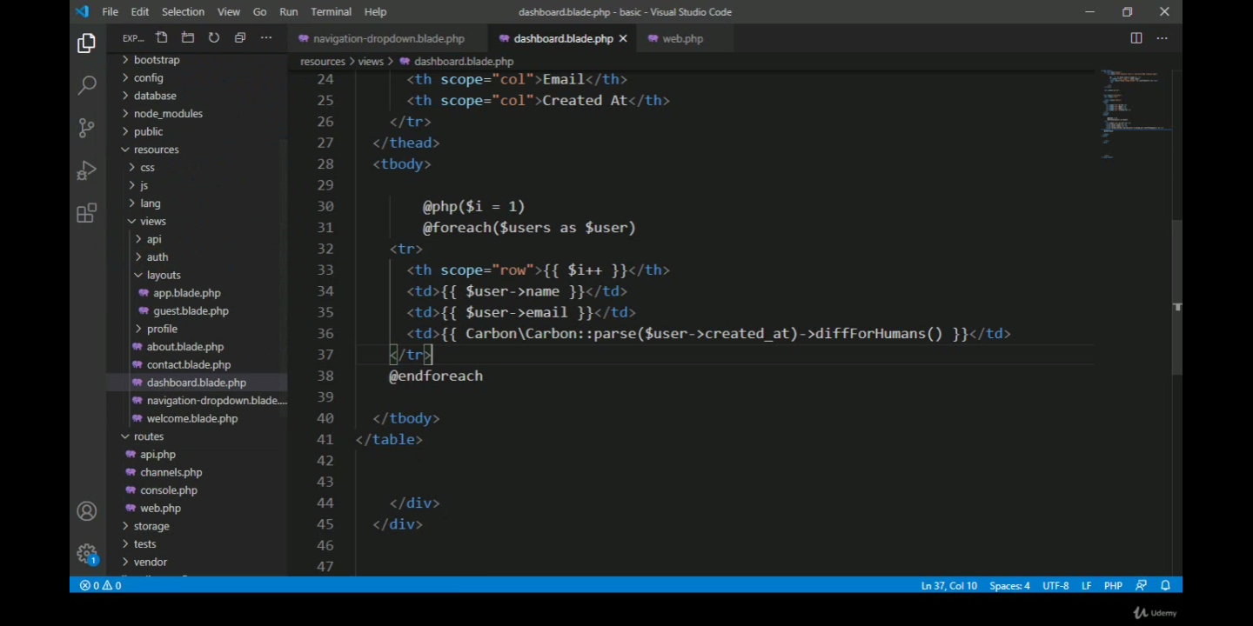

**Create Model and Migration (using full MVC pattern)**

If we want to create a table in Laravel then we will **Migrate** it. This can be done with both **Eloquent ORM** or **Query Builder**.

Using **Eloquent ORM** requires a **model** to be created and used but if we choose to use Query Builder we do not require to create a model.

How to create a **model** and **migration table** simultaneously?

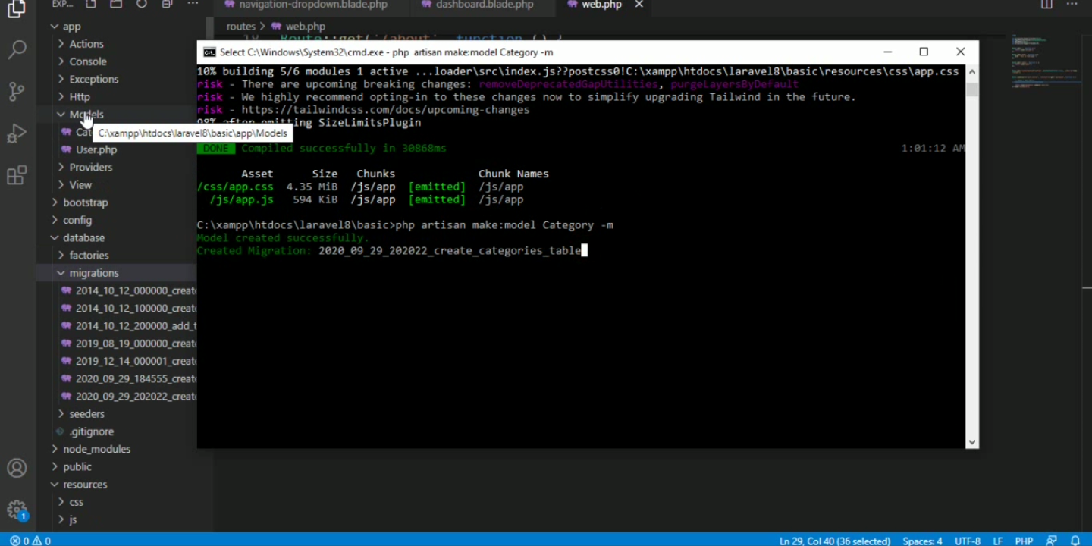

Adding fields to our **migration table** and the use of **softdeletes**

Why **softdeletes** is used?

Soft deleting the data allows us to easily view and restore the data with minimal work and can be a huge time saver when data is accidentally deleted.



**22 |** P a g e

**How to use softdeletes in a model and then use it in a table?**

Here we are using **softdeletes** in a model called Category.

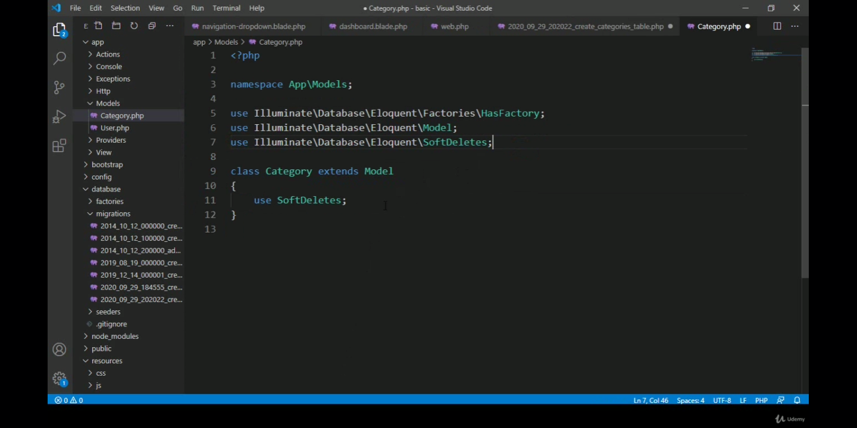

Here we are using **softdeletes** in a table.

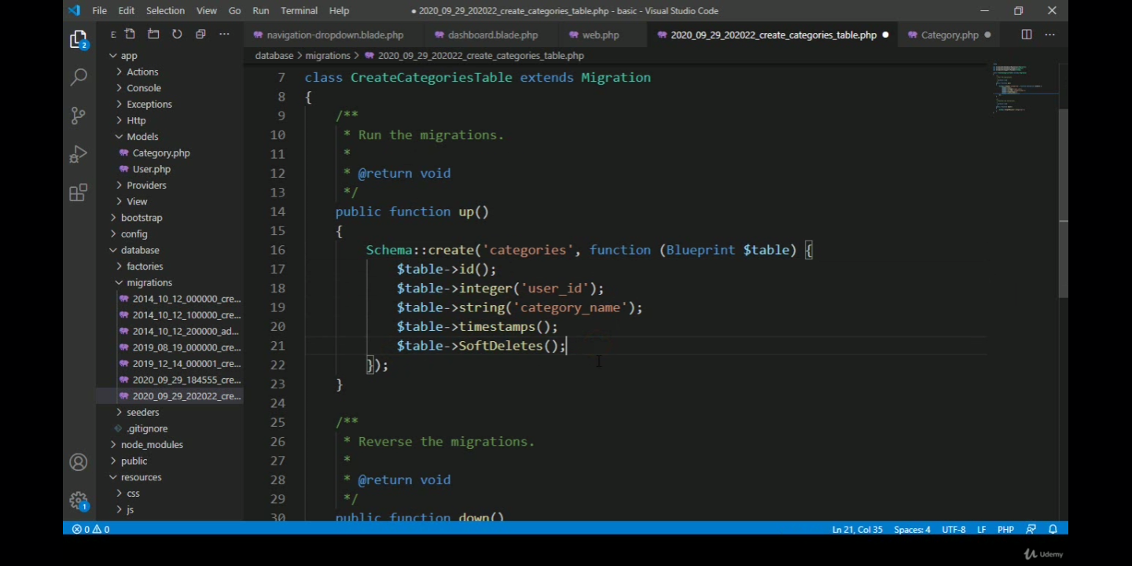

Then finally run the following code to create a migration table called Category

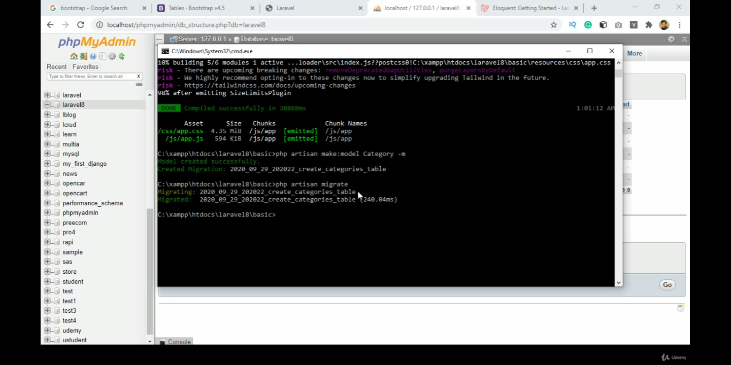

Practice the following

1. Create controller
2. Create route
3. Write a method for the controller to ensure page is redirected



**23 |** P a g e

**Validation**

Assuming that **route** to store.category is already created, without the **@csrf** token we cannot post or insert any data into the database.

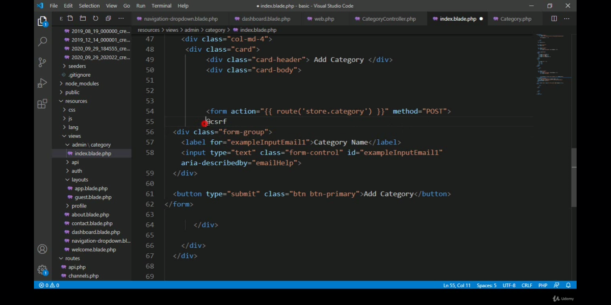

**Syntax for showing error message**

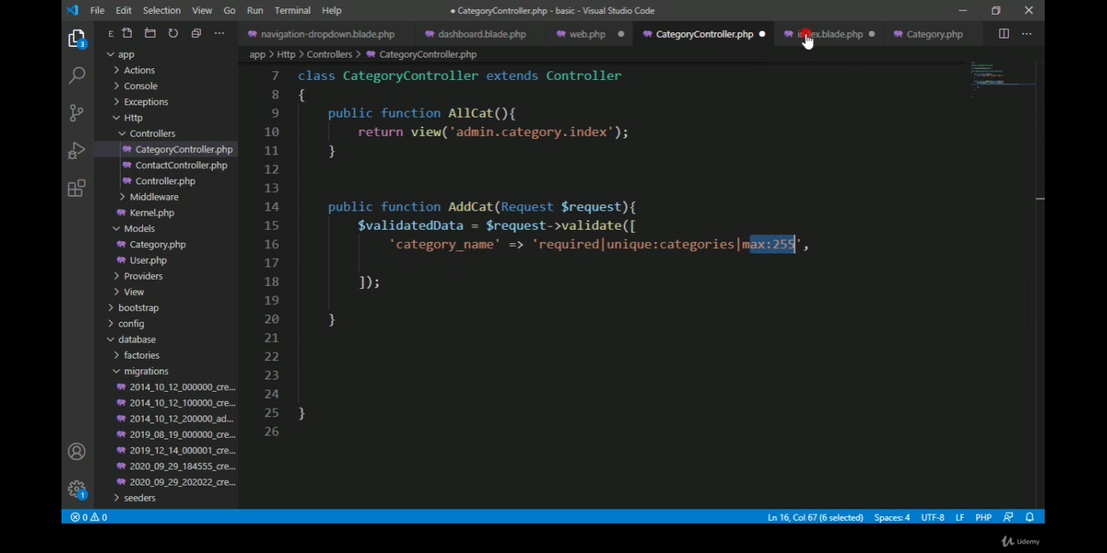

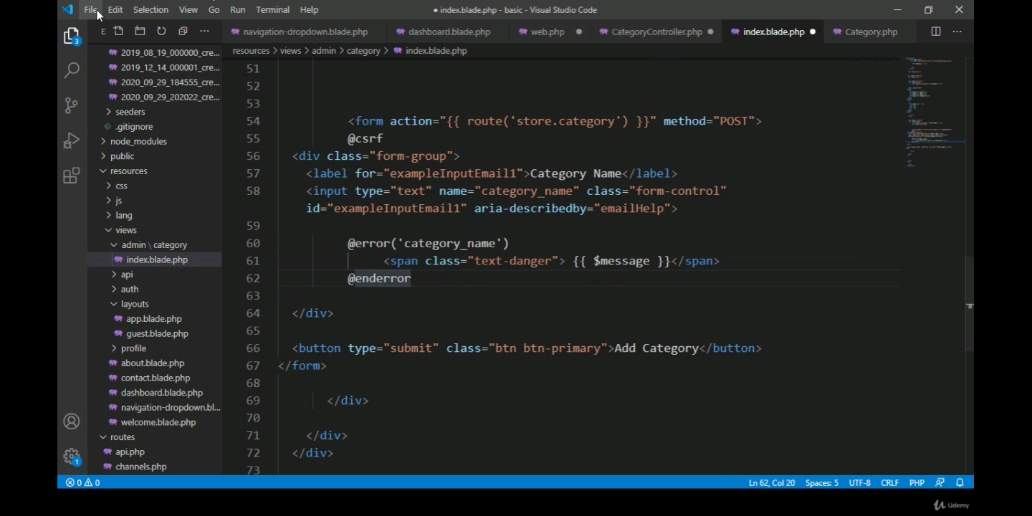

**Note**: Route for this should be set to **post** rather than **get**

**24 |** P a g e

**Syntax for showing custom error message**

In order to show custom error message just use the following syntax

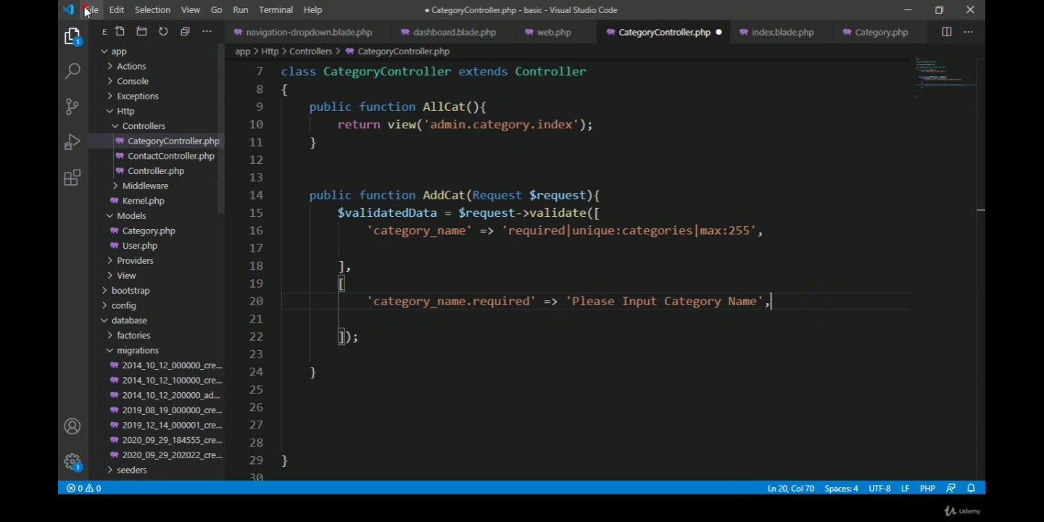

How to insert data using **Eloquent ORM**?

To insert data using Eloquent ORM, first we need to add the **model** name (in this example the model name is Category)

Then we need to **use Carbon, Auth, Category** (model)

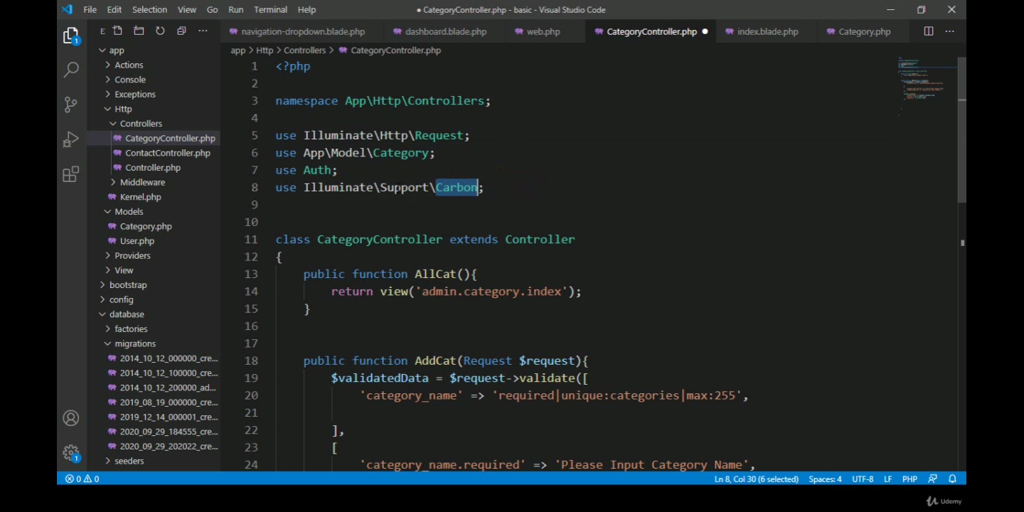

Add the following code snippet to insert data

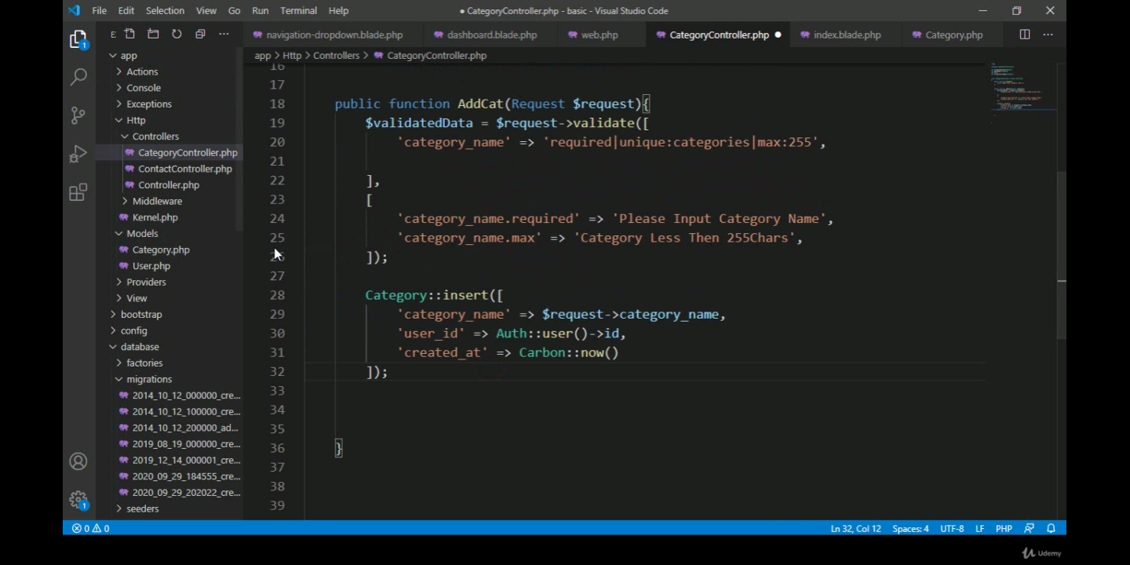



**25 |** P a g e

**Object-oriented approach**

In the object-oriented approach, we need to create an object of the model as shown   
in the following snippet

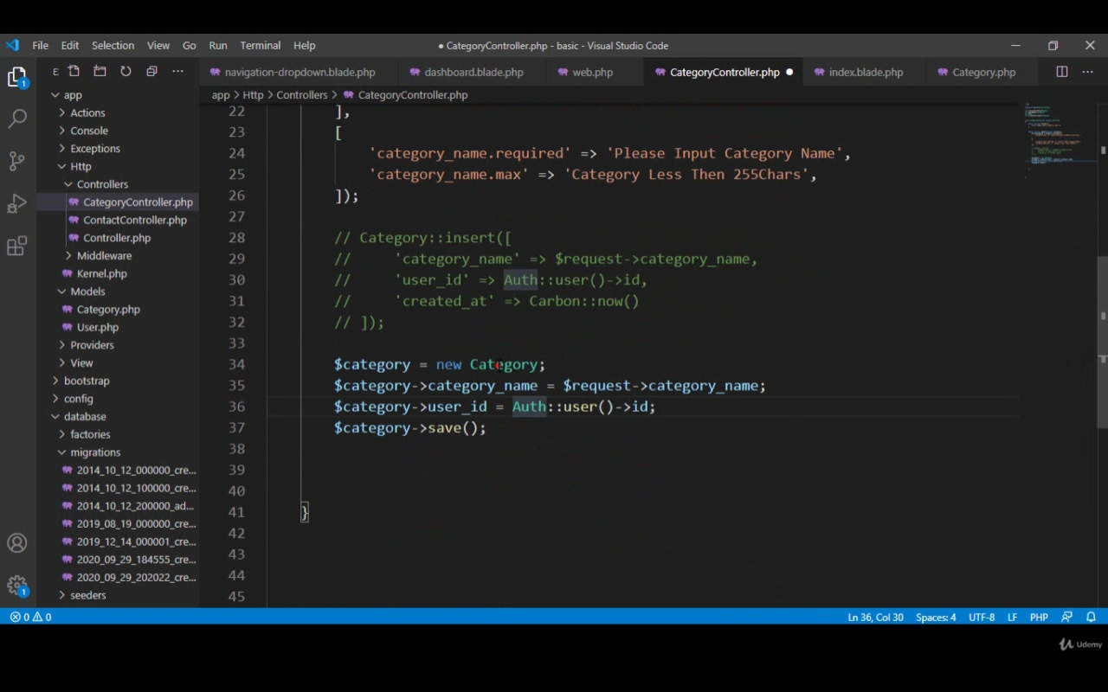

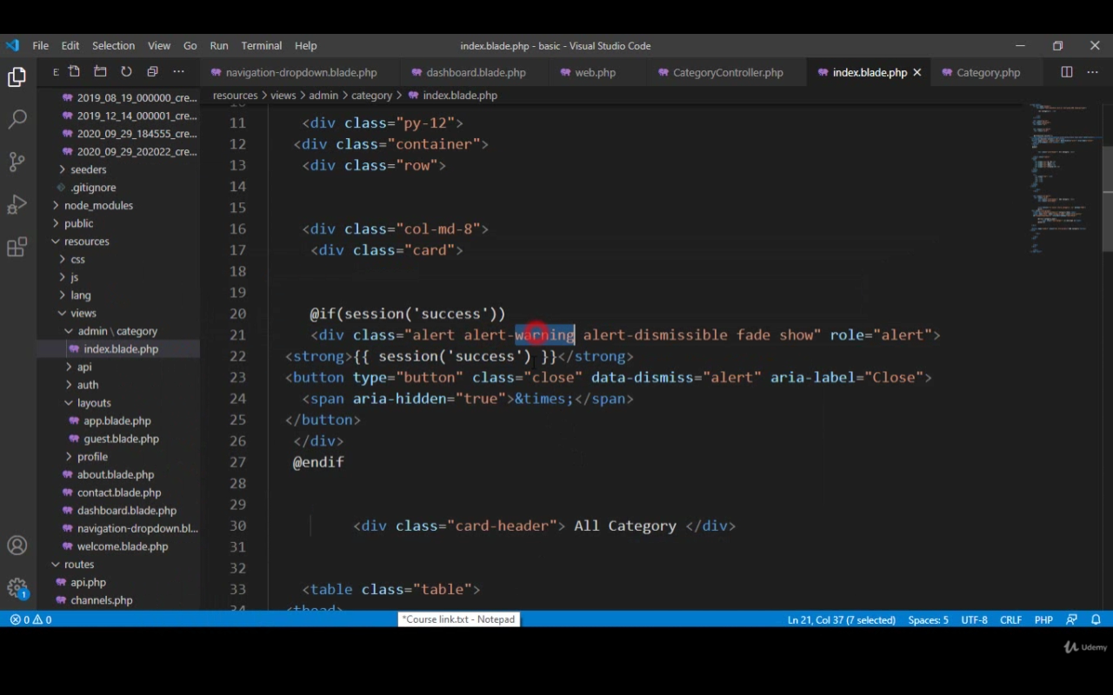



**26 |** P a g e

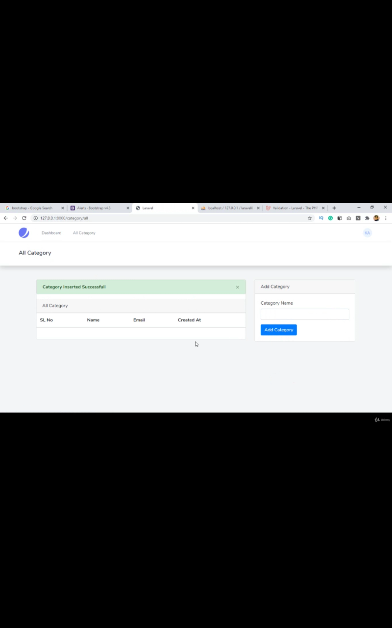

**27 |** P a g e

**Chapter 5**

**Lesson Learned**

**5.1 Problems Faced During this Period**

I have been faced with a few challenges and problems during my period of internship in this firm since it has been a new experience for me and there is the structural process of every step which was difficult to process at the beginning for me but eventually, with observation and understanding of the corporate world I have come over the challenges and my colleagues and project manager have been an inspiration to me while my learning period.

**Understanding the Methodology:**

Understanding the software development life cycle’s methodology’s implementation on real-life projects was interesting and far more difficult to process and implement for me. Understanding the methodology was important and difficult for me since it’s the whole cycle process to develop the system, and understanding how to make it process faster was a task assigned to everyone.

I have figured out in the hard way that one should never attempt to accomplish a project which is beyond the level of his/her understanding and expertise. One should always do enough self-learning to ensure efficiency and acceptance of his/her work in the software industry.  
  
  
  
  
  
  
  
  
  
  
  
  
  
  
  
  
  
  
**28 |** P a g e

**Chapter 6**

**Conclusion**

In my lifetime, I have never experienced such a brilliant and wonderful experience that I have felt being a web developer intern at SSL Wireless. The company has influenced me to break the barriers and stand differently to put out my talent and understand the way how a corporate world works. After facing tremendous difficulties and problems, I finally realized that the path to become an esteemed full stack engineer one must never compromise with consistency and hard-work. Becoming tired upon my performance, my adviser told me several times that “I am not a teacher who will try his/her level best to feed the several technical aspects of software engineering. It is you who will have to earn the ability learn by yourself, ask questions to others, have an open mind to discuss and never be shy of your inferiority”. The company inspired me to focus on different aspects of my life and that I could become more if I put my dedication into it, for which I will be forever grateful for the firm.

The project assigned to me helped me learn many things about web development, such as JavaScript, HTML, CSS, PHP, MySQL and many other tools. SSL Wireless has made me learn and motivate myself, which will forever live within me. I’d like to express my gratitude to the team and everyone at the firm for letting me have the opportunity to be amongst them.

**29 |** P a g e